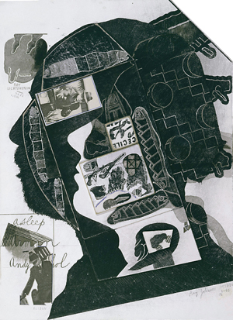 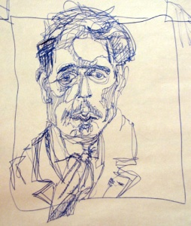Making Your Mark

Day One: Contour Drawing of Still Life
Day Two: Gesture Drawings of models
Day Three: Puzzle piece and value study
Day Four: Texture squares and printmaking
Day Five: Metamorphosis
Day Six: Photo Collage in style of David Hockney
Day 7-10: Silhouette Self Portrait Performance Task

Six day sketchbook exploration:
For these one day projects, you will be expected to show a great deal of effort and diligence. Following instructions and staying on task will be essential. You will have a beautiful variety of drawing and mark making techniques to show for your hard work. Each day, we will focus on a new creative process. Please come to class ready to take risks and step out of your comfort zone.
If you miss a day of class, you will be asked to come for a tutorial and do homework to catch up.

Performance Task:
This project is an exploration in to the elements and principles of art and design. You must understand how to use these in order to create a bold and original personal piece of art. You will be creating a silhouette self portrait. The only specific instructions are that you must use your silhouette stencil two times, you must include details that show something of your personality, you can only use black, white and one other colour, and you must use three of the above techniques.

How do I succeed?
- Your canvas must show originality and creativity. It must be different and unique. (SELF EXPRESSION)
- Your painting and must be neatly and carefully crafted and be eye-catching from five meters away.(TECHNIQUE)
- Your art must include personal symbols and representations, so that your audience will know you better. (HISTORY AND CULTURE)
- You must use class time wisely and show a great amount of effort. (PERSONAL MANAGEMENT)

Essential Questions:
How can personal details make art more interesting?
How can we make art that is original?

