Acrylic Paint-Australian Aboriginal Life Map
Exploring Symbolism
Ms. Morgan
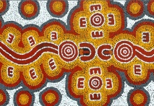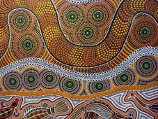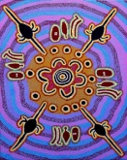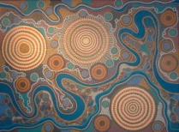

Essential Questions:
- How do you make a successful design with ten symbols?
- How does repetition create movement? SHOW ME.
- How do symbols change, depending on the society?
- What three principles of design do you think are most important in these styles of art? WHY?

Emphasized Standards:
3-Self Expression, 4- Technique, 5-History and Culture

Idea Development: (In sketchbook)
- Map your life so far. Recall ten major events/memories/people/places/ and symbolize each one.
- Your symbols must be simplified and innovative. (INVENT YOUR OWN LANGUAGE)
- Use these symbols to design a composition (Three thumbnail sketches)
- Choose your favourite composition and draw it in to foam
- Print two life maps
- Very valuable Value Scale in Acrylic Paint

Final Work:
- With your dichromatic palette, begin by painting a background
- Using stencils, back of brush, sponge, create major shapes on your board.
- Using acrylic paint and stencils, back of brush, sponge, create major shapes.
- Paint the outlines and details. REFINE
- Have 3 people critique you

Success Questions
- Does your design have UNITY? (TECHNIQUE)
- Does it POP from three meters away? ( TECHNIQUE)
- Have you done something unique and original? (SELF EXPRESSION)
- Have you used symbolism to invite your viewer in and peak curiosity? (HISTORY AND CULTURE)

Extension:
Create a map of your bedroom in the style of the Australian aborignals
Use three stencils to create a painting on cardboard in the style of the Aborigines.
Create a 5-7-5 Haiku poem about your life map.

