Conceptual Art in Clay
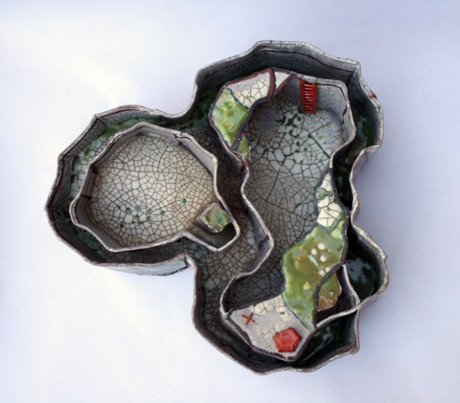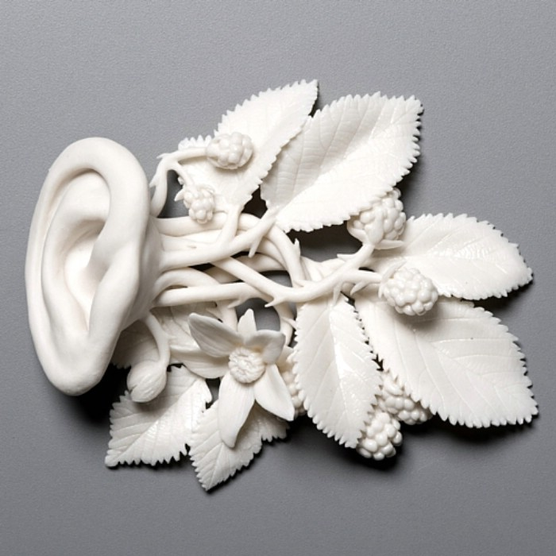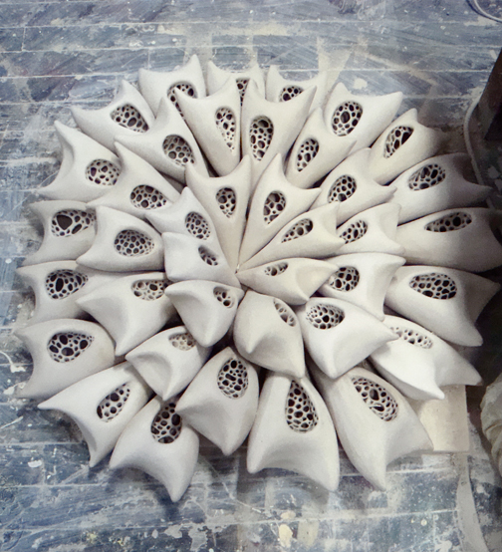
Boazlevi Anonymous Amanda Small

Emphasized Standards:
1-Creating 2-Language of Art 3-Self Expression

Introduction:
While making conceptual Art the idea or concept is the most important aspect of the work. The emotional response of the viewer is taken in to account and the concept is communicated through the elements of art and principles of design.

Ideas Development in Sketchbook:
You must find six images that are properly cited and next to each, an explanation of why those were chosen. A full plan with colour of what you will be creating in clay.

Performance Task:
You will be choosing an emotionally rich word that you must then sculpt conceptually in clay. For example, you get the word “JOYFUL” and you must sculpt that concept in whatever way you envision it. You will also be focusing on one of the principles of design, but that will be left up to you.
In your sculpture you may use slab, coil, pinch, and the four S method to create your piece. It could be a sculpture in the round or a relief sculpture. Your clay must be professionally rendered and refined and must evoke an emotional response in your audience.

Questions For Success:
- Have you gone through the entire design cycle in order to create a refined and highly original piece of art?
- Have you used the elements and principles to make something original and unique?
- Is your principle of design included?
- Have you sculpted something that shows your concept in a surprising way?

