Buste Out!
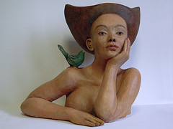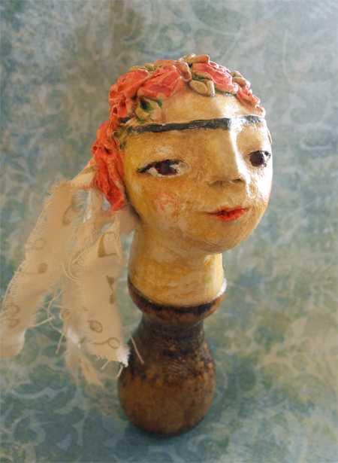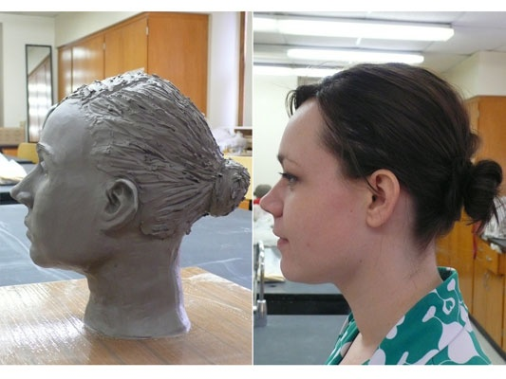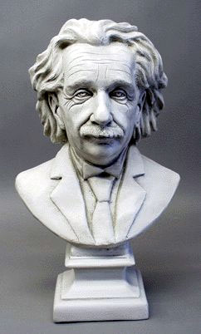
Melanie Bourget Joyce Van Der Lely Maggie Ryan no name

Emphasized Standards
Creating Technique Critique

Introduction:
Today we challenge ourselves by sculpting something timeless…the buste! The emotional response of your viewer is important and the use of the design principles is key to the overall success of your piece. What feeling do you want your audience to have? What do you want to convey about the person? What do you want to show about yourself? What might be left “hidden”? What are the technical challenges you might face? How do your peers help you during the creative and critiquing process?

Ideas Development:
You must find four to five images that relate to your overall idea. The rough draft must show enough detail, that I will know exactly what your goal is for this project. Please do not make your first idea. Go through the design cycle to arrive at the best and most interesting idea. You must work from a three photographs of yourself. From the front and side and back. You may skew or abstract rather than expressing realistically, but your buste is your starting point.

Performance Task:
You will create a buste in clay that is full of life and personality. The knowledge you have of clay technique, must be applied while you sculpt, discuss, and critique the projects. You may use other materials, if it adds to the overall effect.

Questions For Success:
Have you gone through the entire design cycle in order to create a refined and highly original piece of art?
Have you used proper clay technique?
Have you encouraged your peers through this process?
Are you open to others’ interpretations and criticism of your art? HOW?

