Grid Drawings
Based On Personal Photographs
ARTrageous

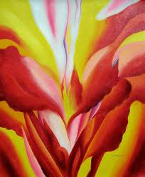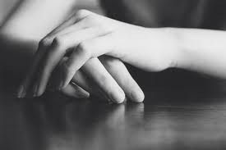
Georgia O’Keefe Woods Wheatcroft Creative Commons Marie Killen

Emphasized Standards
1- Creating, 3- Self Expression, 4- Techniques, 5- History and Culture

INTRODUCTION and Performance Task
You will be compiling a collection of photographs of your chosen “theme” or subject. These include “Looking For Light”, “Up Close”, “Woods Wheatcroft”, or Self Portrait. You will create a small artist blog to showcase these photographs. (jimdo.com) You will then choose your favourite two and create a final and photo-realistic drawing (Grid) in pencil and oil pastel. This drawing will be a diptych, meaning it will contain two drawings: one pencil and one oil pastel.

IDEAS DEVELOPMENT (IN SKETCHBOOK)
-You will research your subject matter or theme. What are other artists doing in the world of photography? What strikes you or connects with you? Why do you like what you see?
-Ten personal photographs uploaded and then shared on jimdo.com
-Two contour drawings of your overall photos in your sketchbook.
-Thoroughly thought out plan for your diptych.

Success Questions (linked to each standard)
1. Have you used the design cycle to thoroughly research, plan for, revise, and create a strong and visually bold drawing?
3. Is your diptych surprising, original, and personal? How?
4. Does your piece show high quality, well controlled and confident technique? Is it obvious that you understood the use of the grid and a full range of value?
5. Does your drawing and your photography show a connection to your original research and or artist? How? Is your piece personal and does it connect somehow to your own culture or generation? How? Why is that important?

