Exploring the Elements of Art
Scribble Exploration and Enlargement
Ms. Morgan

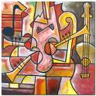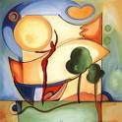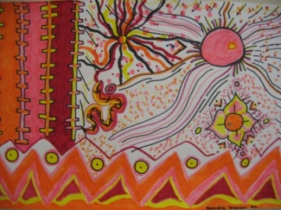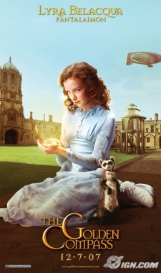

Essential questions:
- How can we create art work which is unique?
- Where do we see the elements of art in the world?
- Why is revising our art so important?
- When should we ask others to give their opinion of our work?
- Why do artists “limit their palette”?

Emphasized Standards (refer to assessment sheets for details)
1. Creating 3. Self Expression 4. Technique

Introduction
-You will do a “scribble exploration” to get warmed up. This will include five of the elements of art

Idea Development (In Sketchbook)
-In your sketchbook please do two “mini” enlargements in pencil first (8 by 8).
-Outline the pencil with black sharpie.
-Then choose hot or cold colours to fill in your art showing the new blending technique.

Final Work
-You will choose your favourite “mini” and create your final art work on a separate piece of paper in oil pastel.
-From this step, you will do an “extension”.
This extension must include your own “daemon”.
Your lines must extend in to your drawing, so that it is connected.
Opposite colours must be used directly next to your oil pastel square.
You may choose coloured pencils, oil pastels, and black marker for this performance task.

Questions For Success:
Does your art have a full range of value and have you improved in this technique?
Have you used blending in a way that shows smooth transitions?
Have you demonstrated an understanding of contrast and hot and cold colours?
Have you used your imagination? Have you done something truly surprising and original?

*Remember to always “ASK THREE BEFORE ME!”
Extra time?
- Do another one using earth tones. How does this change the feeling of your art?
- Do another “scribble exploration”, but this time write down your own 10 rules.

