Pocket of Snuggles
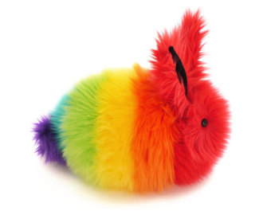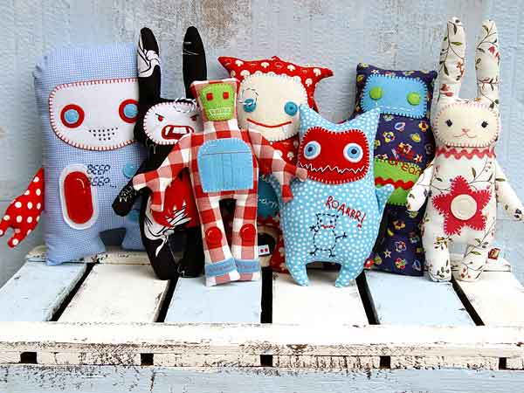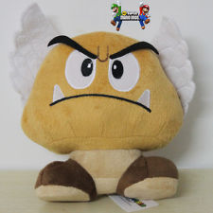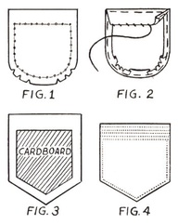

Emphasized Standards:
1-Creating 4-Technique 3-Self Expression 5-History & Culture

Introduction:
You are a toy designer. You are creating a stuffed creature for a child who moves around a lot. What kind of creature will give comfort, a sense of home, and a personal feeling of well-being?

Ideas Development in Sketchbook:
You must first brainstorm five ideas for your creature/toy. What kind of character or personality will it have? What emotion will it convey? What will it hold in its pocket? (Each one will have a pocket, which holds a symbol of home) What materials will you use? After finishing your brainstorm, you may research and choose some inspiring images or helpful sources. You will then create a template for each part of your creature’s body. Steps must be written down, so that you can follow them to make your toy. (Ms. Morgan will do a demo)

Performance Task:
You will be creating one unique, properly constructed, personally connected stuffed creature. Your creature must be sewn together properly and securely. It must show your unique style and personality. The pocket is the place to exhibit your personal connection to home.

Questions For Success:
- Have you gone through the entire design cycle in order to create a refined and highly original piece of art?
- Is your work high quality, well controlled, and confidently refined?
- Have you sculpted something that shows your concept in a surprising way?
- Is your style and personality apparent?

Schedule:
Two days for Ideas Development and template design.
Four days for sewing. Due Date: April 29 (Before art show)

